**Bonzo’s Adventures in Wonderland Goals and Evalutations**  
  
*Disclaimer: This is an attempt to rewrite what I have already written on another word document. I believe it is/was in the old team, which I cannot access.*

Bonzo’s Adventures in Wonderland will be an exploration game in a pre-determined map in which you, playing as Bonzo the dog, must travel around and find hidden items. Some items will give you certain abilities, but most will just give you points. These items could include a ball, a bone or other things. There will be savegames which you can rename and wipe at will, along with a scores system that shows the savegames in order of scores. In the game, there would be a timer. When this timer runs out, your score would be presented to you and the game is over. Hopefully this game will be enjoyable and not too complicated to understand!

Flowchart is on another document (see disclaimer at top of page)

Objectives:

* The game must be enjoyabl
* The game must have savegames
* The game must have a score system
* The game must be an exploration game
* The game must have a timer
* The savegames must be editable
* There must be collidables in the game that can be handled by the code
* The item pickup system must be easy to use and reliable
* The game must have animations and nice textures, it must be aesthetically pleasing and interesting
* Create enemies with AIs­­

**The following information is not on the other document mentioned in the disclaimer**

Testing:

Test of menu:  
(Menu)  
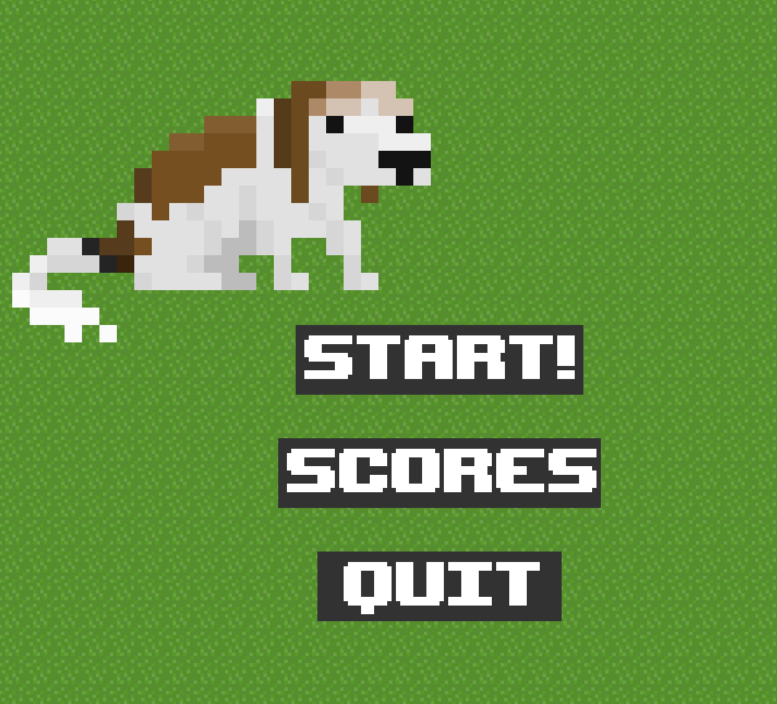  
(After clicking Start)

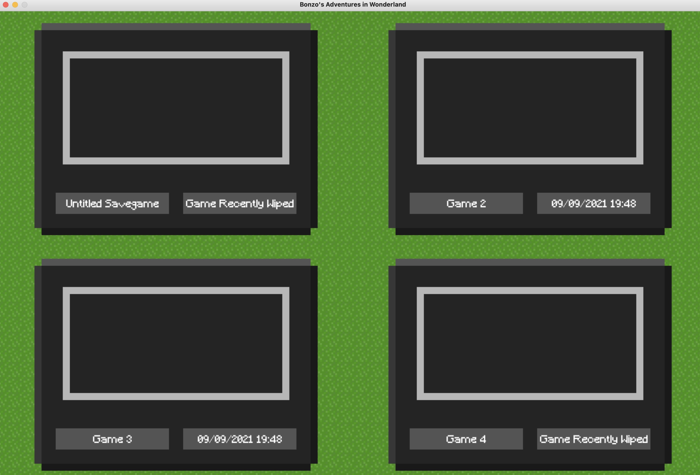

(After clicking Scores)

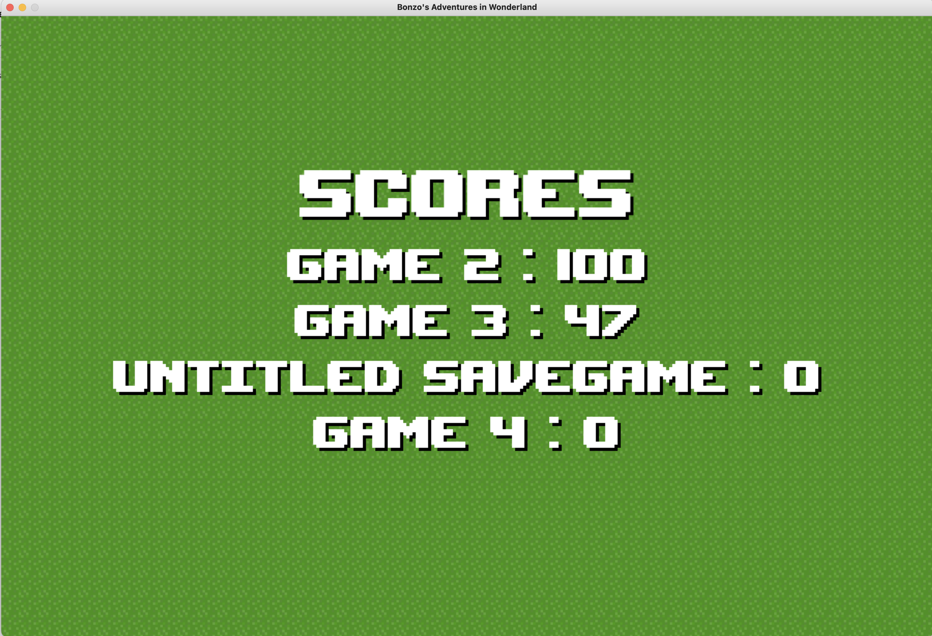

(After clicking Quit) (Its closed)

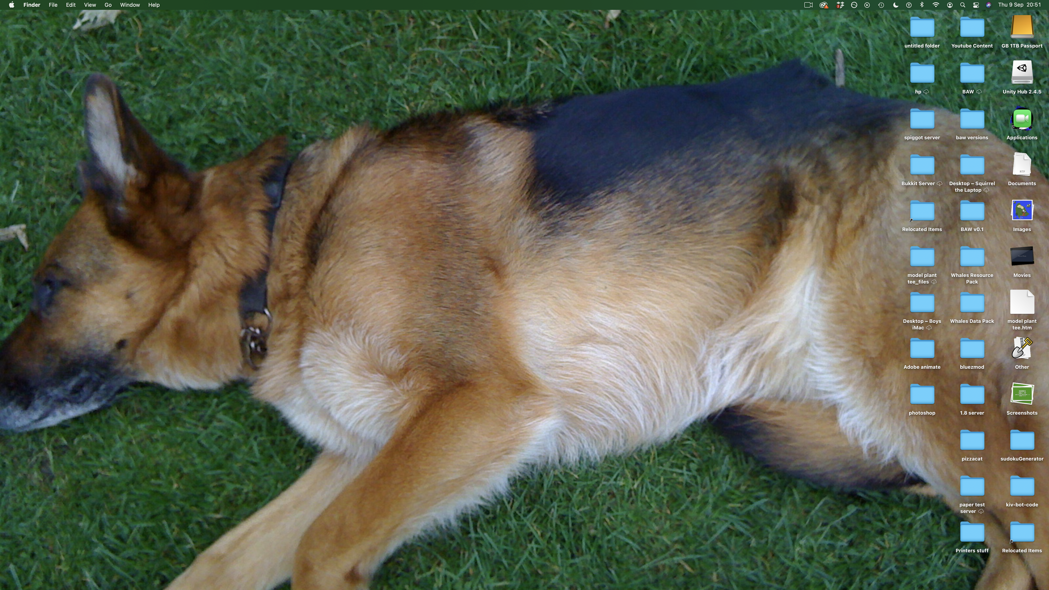

Tests of user input validation:

(If you do not enter a name for your savegame, the game will just not rename it)

(1, renaming with nothing)

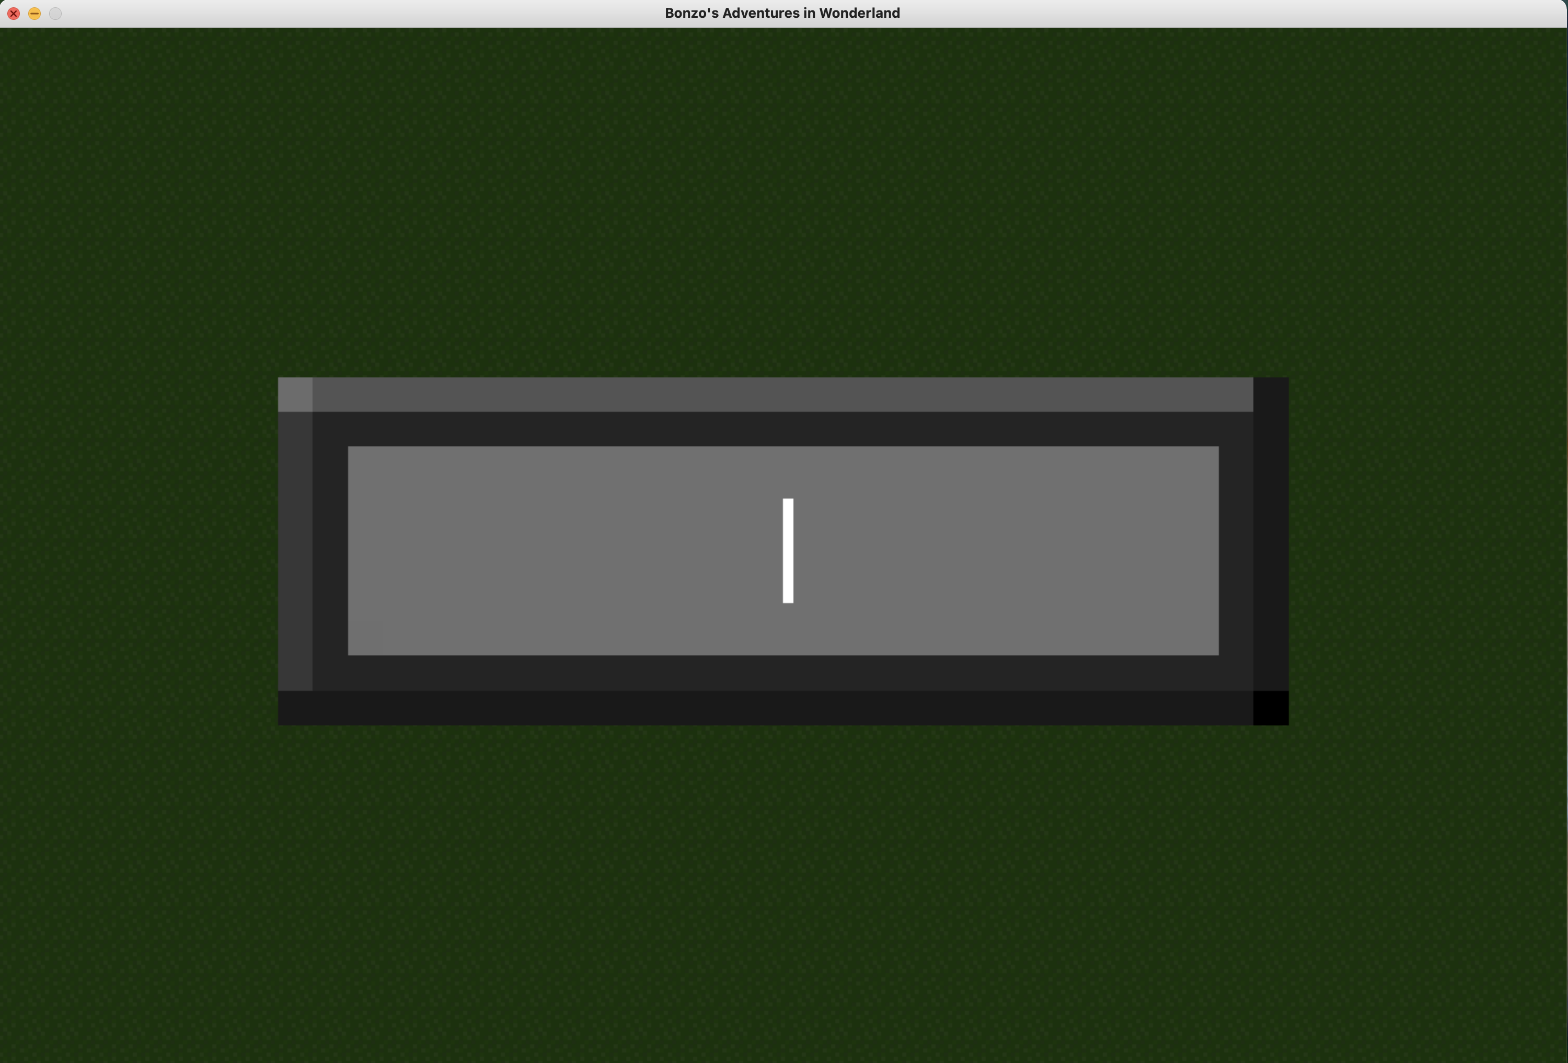

(2, Name is not changed)

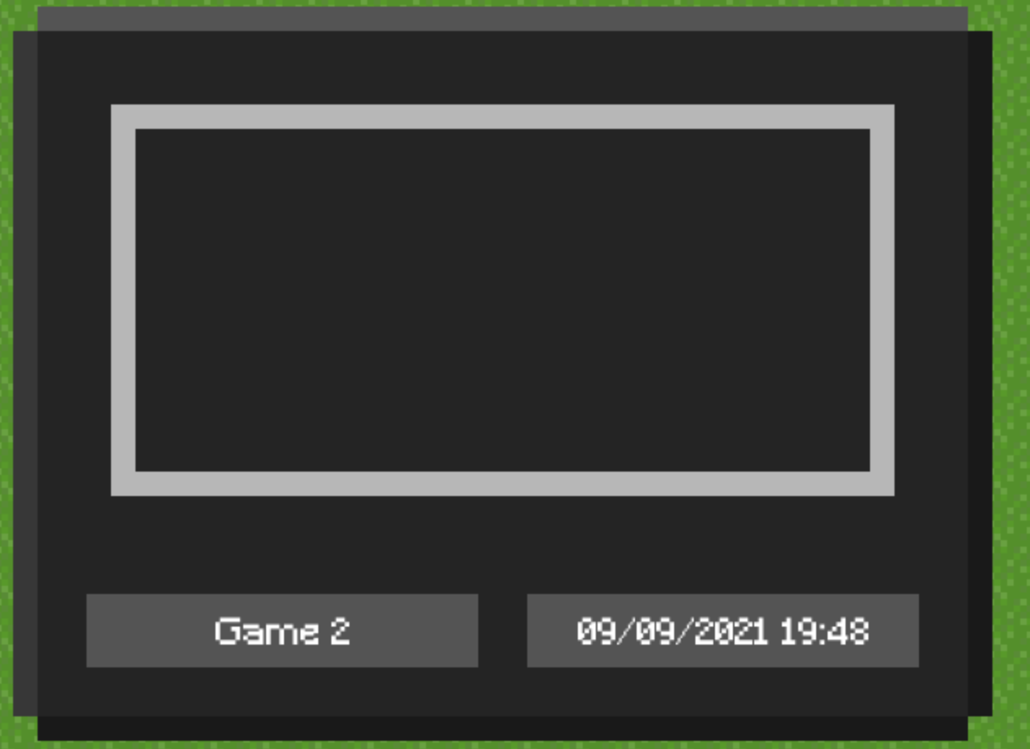

(Pressing the W key if there is a collidable above you stops you moving upwards)

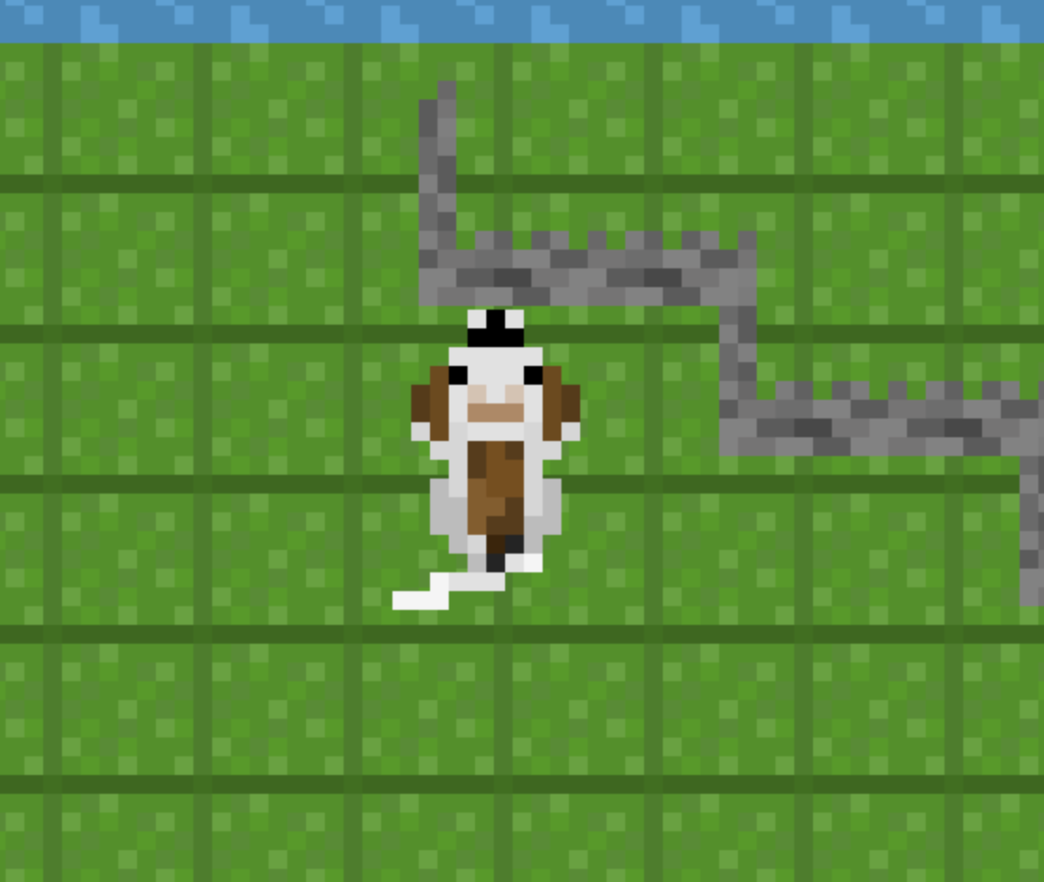

(You cannot leave the map)

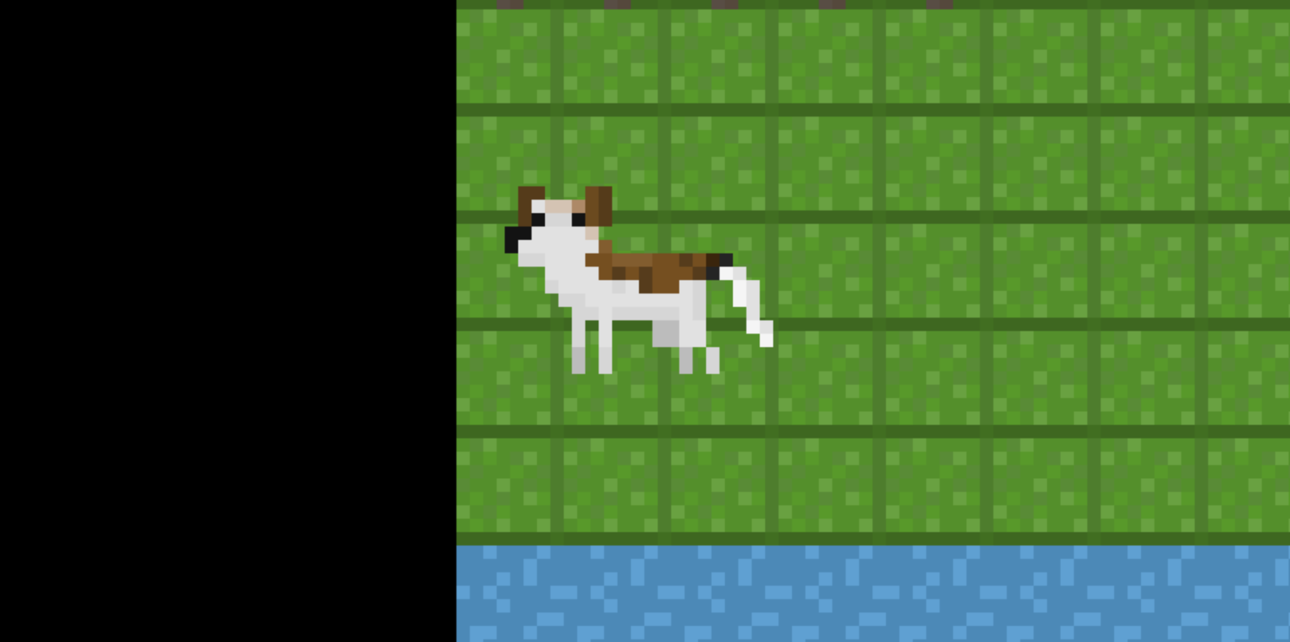

Other Tests:

(Test to show score is generated)  
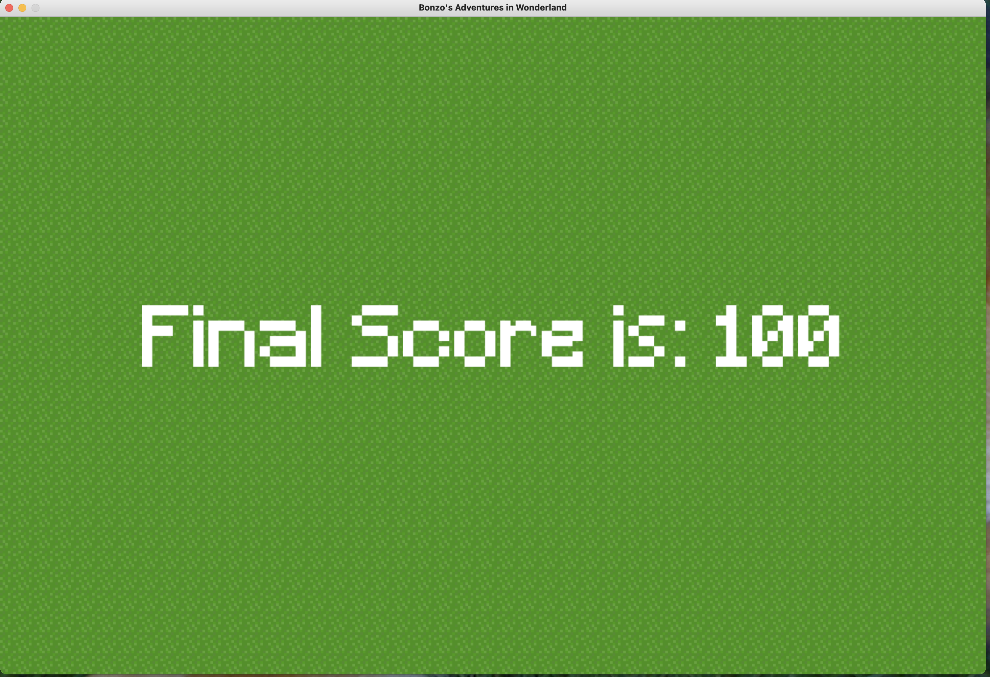

(Test showing the scores are stored and a leaderboard feature works)



(Test showing the game works)

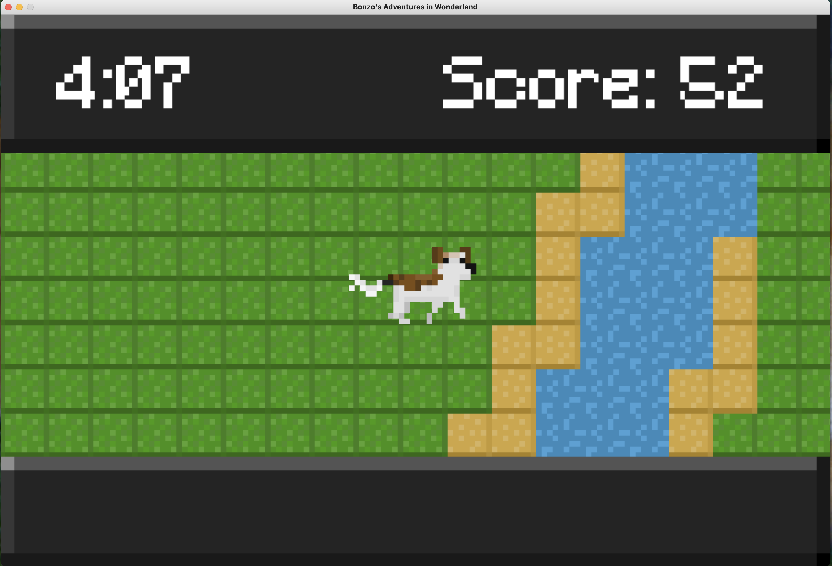

(Test showing collidables work)



(Test of Savegame being wipeable)

(Before wiping)  
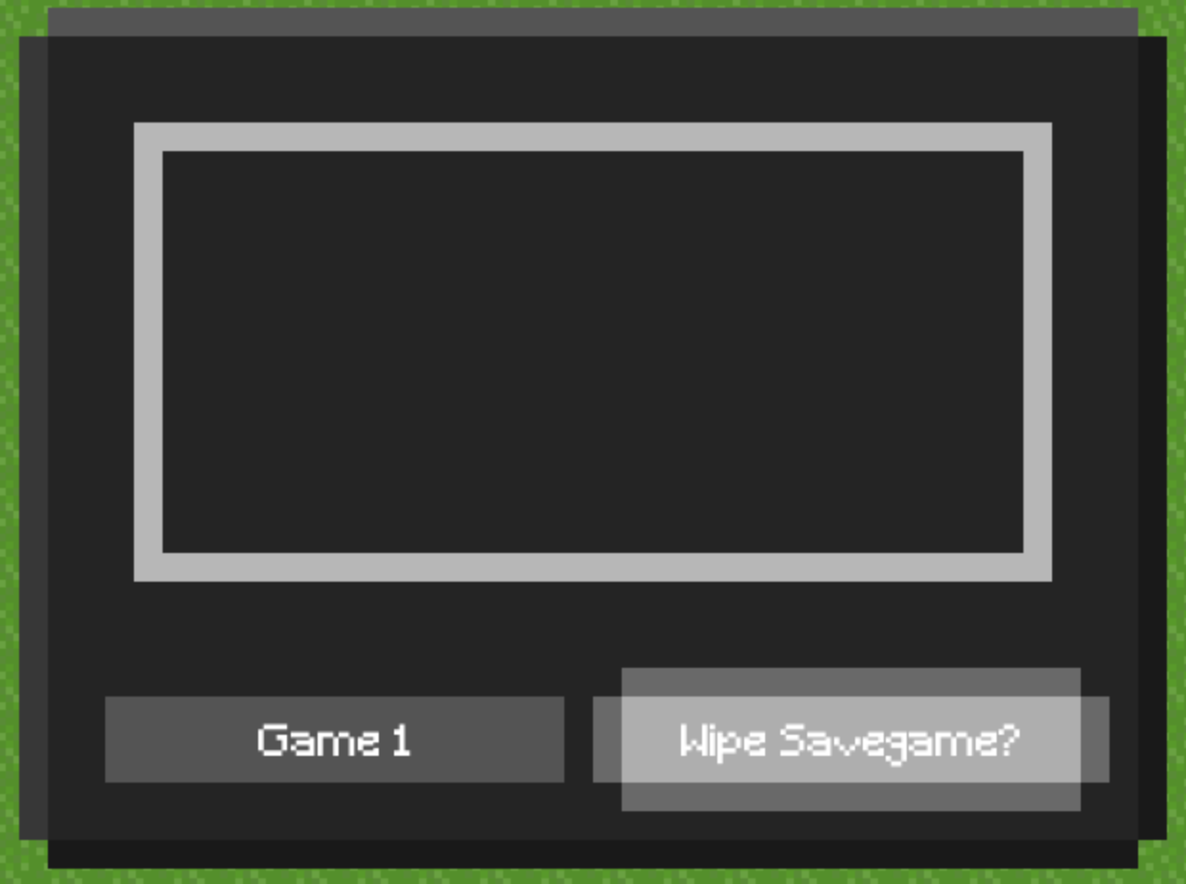  
(After wiping)

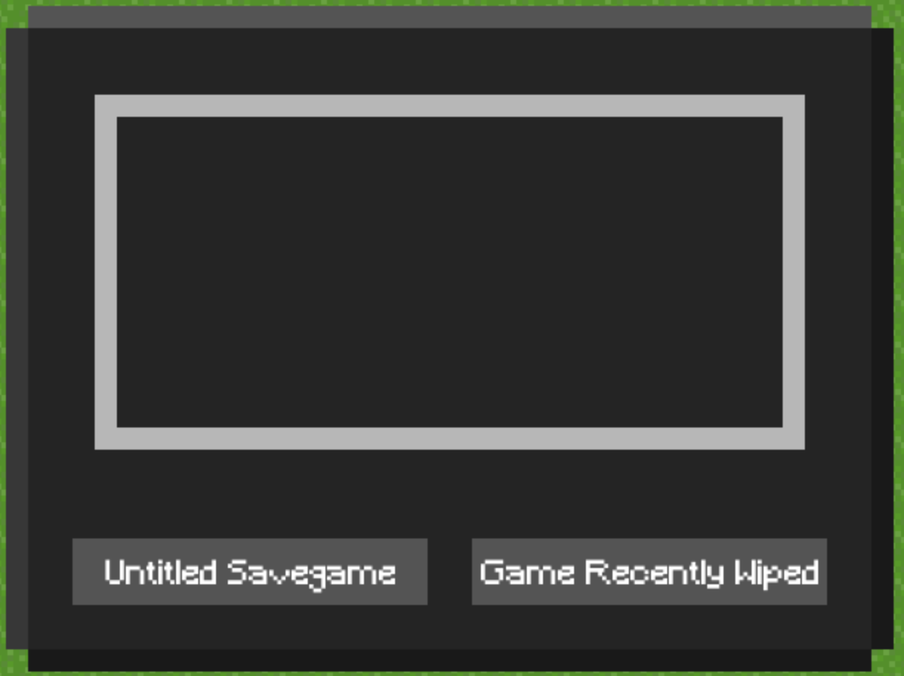

Evaluation:

* **The game must be enjoyable**

Although I consider the game fun, I have to admit that I am biased, and many may find it dull and repetitive, since after the map has been fully explored, the game becomes easy. I could fix this with an energy bar, but I sadly do not have time for that.

* **The game must have savegames**I achieved everything I wanted to with my savegame goals, having made them (the savegames), wipeable, renamable, playable and easy to access.
* **The game must have a score system**The game’s score system is easy to understand and use, which is a positive, however making it more complicated would add another layer of depth to the game, making the player more likely to spend longer at it. Sadly, I have not made it very complicated, that will be saved for a later version of the game
* **The game must be an exploration game**The idea of the game is that the player explores the map, finding and picking up items. Since the map is quite large, I would consider it an exploration game; you have to explore the map to get a higher score. Some high scoring items are hidden on islands or atop rocks, or in the middle of forests.
* **The game must have a timer**

The timer defines the game. Without it, the game goes on endlessly and a max score is possible. Therefore I have made it such that when the timer finishes, you are given your final score. This works smoothly and cannot be broken, attempting to re-enter a game after it is completed will just show the completion screen instead.

* **There must be collidables in the game that can be handled by the code**Some tiles in the game (bushes, fences and walls) will prevent you going through them at all. Water will require a raft to cross (I would have added an animation for using the raft, but I did not have time to create the assets), and other tiles are free to walk on whenever.
* **The item pickup system must be easy to use and reliable**

Standing on an item and pressing E will always pick it up. This is completely reliable. I would have made it easier if I knew how, but I couldn’t think of a way to make it easier without a lot of code.

* **The game must have animations and nice textures, it must be aesthetically pleasing and interesting**

I am very proud of the extent to which I completed the assets goal, as in my opinion the assets are very neat but also bright!

* **Create enemies with AIs**

Creating AI’s was a task I deemed too complicated with the given time and my current knowledge. I may do this in a future version, but it would be very complicated and buggy. Therefore I have not completed this goal.

I believe that I have achieved most of my goals. If I were to continue development on this game I would most likely rewrite it in a different language, improving the efficiency and elegance of the code. I would also turn the game into a survival game, but that’s a project for another day.

­­